
LAB-1-2 Last Checkpoint: a few seconds ago (autosaved) 

Python [default]
- File
- Edit
- View
- Insert
- Cell
- Kernel
- Widgets
- Help

%matplotlib inline
import torch
import torchvision
import torchvision.transforms as transforms
import torchvision.datasets as datasets
def get_mean_and_std(dataset):
'''Compute the mean and std value of dataset.'''
dataloader = torch.utils.data.DataLoader(dataset, batch_size=1, shuffle=False, num_workers=2)
​
mean = torch.zeros(3)
std = torch.zeros(3)
print('==> Computing mean and std..')
for inputs, targets in dataloader:
for i in range(3):
mean[i] += inputs[:, i, :, :].mean()
std[i] += inputs[:, i, :, :].std()
mean.div_(len(dataset))
std.div_(len(dataset))
return mean, std
#To determine if your system supports CUDA
print("==> Check devices..")
device = 'cuda' if torch.cuda.is_available() else 'cpu'
print("Current device: ",device)
​
#Also can print your current GPU id, and the number of GPUs you can use.
print("Our selected device: ", torch.cuda.current_device())
print(torch.cuda.device_count(), " GPUs is available")
#device = 'cpu'
==> Check devices..
Current device: cuda
Our selected device: 0
1 GPUs is available
print('==> Preparing dataset..')
==> Preparing dataset..
"""1.1"""
img_size, linear_size, fc1_out, fc2_out = 64, 13, 128, 84
#img_size, linear_size, fc1_out, fc2_out = 128, 29, 256, 84
#img_size, linear_size, fc1_out, fc2_out = 256, 61, 256, 84
#img_size, linear_size, fc1_out, fc2_out = 384, 93, 128, 84
#img_size, linear_size, fc1_out, fc2_out = 512, 125, 256, 84
#img_size, linear_size, fc1_out, fc2_out = 512, 125, 512, 84
#img_size, linear_size, fc1_out, fc2_out = 1024, 253, 256, 84
​
calculate_mean_std = True
​
if calculate_mean_std == True:
#The transform function for train data
transform_train = transforms.Compose([
transforms.Resize(img_size),
transforms.RandomCrop(img_size, padding=4),
transforms.ToTensor(),
])
​
#The transform function for test data
transform_test = transforms.Compose([
transforms.Resize(img_size),
transforms.RandomCrop(img_size, padding=4),
transforms.ToTensor(),
])
​
#we will calculate mean and std

trainset = torchvision.datasets.ImageFolder(root='./food/training', transform=transform_train)
testset = torchvision.datasets.ImageFolder(root='./food/evaluation', transform=transform_test)

train_mean, train_std = get_mean_and_std(trainset)
print(train_mean, train_std)
test_mean, test_std = get_mean_and_std(testset)
print(test_mean, test_std)
else:
train_mean, train_std = ([0.5551, 0.4478, 0.3366]), ([0.2337, 0.2414, 0.2386])
test_mean, test_std = ([0.5607, 0.4518, 0.3425]), ([0.2333, 0.2415, 0.2385])

==> Computing mean and std..
tensor([0.5287, 0.4255, 0.3181]) tensor([0.2498, 0.2446, 0.2321])
==> Computing mean and std..
tensor([0.5337, 0.4291, 0.3238]) tensor([0.2499, 0.2450, 0.2327])
"""1.1+"""
#The transform function for train data
transform_train = transforms.Compose([
transforms.Resize(img_size),
transforms.RandomCrop(img_size, padding=4),
transforms.RandomHorizontalFlip(),
transforms.ToTensor(),
transforms.Normalize(train_mean, train_std)
])
​
#The transform function for test data
transform_test = transforms.Compose([
transforms.Resize(img_size),
transforms.RandomCrop(img_size, padding=4),
transforms.ToTensor(),
transforms.Normalize(test_mean, test_std)
])
"""1.2+"""
trainset = torchvision.datasets.ImageFolder(root='./food/training', transform=transform_train)
testset = torchvision.datasets.ImageFolder(root='./food/evaluation', transform=transform_test)
"""1.3"""
​
#Create DataLoader to draw samples from the dataset
#In this case, we define a DataLoader to random sample our dataset.
#For single sampling, we take one batch of data. Each batch consists 4 images
trainloader = torch.utils.data.DataLoader(trainset, batch_size=32,
shuffle=True, num_workers=2)
​
testloader = torch.utils.data.DataLoader(testset, batch_size=32,
shuffle=False, num_workers=2)
classes = ('Bread', 'DairyProduct', 'Dessert', 'Egg', 'Friedfood',
'Meat', 'Noodles-Pasta', 'Rice', 'Seafood', 'Soup', 'Vegetable')
print('==> Building model..')
==> Building model..
import torch.nn as nn
# define your own model
class Net(nn.Module):
​
#define the layers
def __init__(self):
super(Net, self).__init__()
self.conv1 = nn.Conv2d(3, 6, 5)
self.pool = nn.MaxPool2d(2, 2)
self.conv2 = nn.Conv2d(6, 16, 5)
self.fc1 = nn.Linear(16 * linear_size * linear_size, fc1_out)
self.fc2 = nn.Linear(fc1_out, fc2_out)
self.fc3 = nn.Linear(fc2_out, 11)
self.relu = nn.ReLU()

#concatenate these layers
def forward(self, x):
x = self.pool(self.relu(self.conv1(x)))
x = self.pool(self.relu(self.conv2(x)))
x = x.view(-1, 16 * linear_size * linear_size)
x = self.relu(self.fc1(x))
x = self.relu(self.fc2(x))
x = self.fc3(x)
return x
#declare a new model
net = Net()
# change all model tensor into cuda type
# something like weight & bias are the tensor
#net = net.to(device)
print(device)
if device == 'cuda':
net = net.cuda(0)
else:
net = net.cpu()
cuda
########################################################################

3. Define a Loss function and optimize
########################################################################
print('==> Defining loss function and optimize..')
==> Defining loss function and optimize..
import torch.optim as optim
​
#loss function
criterion = nn.CrossEntropyLoss()
#optimization algorithm
optimizer = optim.SGD(net.parameters(), lr=0.001, momentum=0.9, weight_decay=1e-5)
########################################################################

4. Train the network
Before training the model, we need to analysis the tensor variable.
Each variable have many attibute, like: .grad_fn, .require_grad, .data, .grad...etc. The ".grad_fn" attribute of "torch.Tensor" is an entry point into the function that has create this "torch.Tensor" variables. Because of ".grad_fn" flag, we can easily create a computing graph in the form of DAG(directed acyclic graph).
And then, the ".require_grad" attribute allows us to determine whether the backward propagation function is going to calculate the gradient of this "torch.Tensor" variable. If one variable has a false value of require_grad, it represent that you don't want to calculate this variable's gradient, and also its gradient will not be updated.
########################################################################
print('==> Training model..')
==> Training model..
#Set the model in training mode
#because some function like: dropout, batchnorm...etc, will have
#different behaviors in training/evaluation mode
#[document]: https://pytorch.org/docs/stable/nn.html#torch.nn.Module.train
net.train()
#scheduler = torch.optim.lr_scheduler.StepLR(optimizer, step_size = 1, gamma=0.5)
​
for epoch in range(60): # loop over the dataset multiple times
#scheduler.step()
running_loss = 0.0
correct = 0
for i, (inputs, labels) in enumerate(trainloader, 0):

#change the type into cuda tensor
if device == 'cuda':
inputs = inputs.cuda(0)
labels = labels.cuda(0)
else:
inputs = inputs.cpu()
labels = labels.cpu()
​
#print(labels)
#print(inputs)

# zero the parameter gradients
optimizer.zero_grad()
​
# forward + backward + optimize
outputs = net(inputs)
# select the class with highest probability
_, pred = outputs.max(1)
# if the model predicts the same results as the true
# label, then the correct counter will plus 1
correct += pred.eq(labels).sum().item()

loss = criterion(outputs, labels)

loss.backward()
optimizer.step()
​
# print statistics
running_loss += loss.item()

print('%d epoch, training accuracy: %.2f%%, loss = %.4f' %
(epoch+1, 100.*correct/len(trainset), running_loss/len(trainset)))
print('Finished Training')
1 epoch, training accuracy: 15.13%, loss = 0.0727
2 epoch, training accuracy: 21.12%, loss = 0.0688
3 epoch, training accuracy: 23.50%, loss = 0.0665
4 epoch, training accuracy: 26.30%, loss = 0.0649
5 epoch, training accuracy: 27.91%, loss = 0.0636
6 epoch, training accuracy: 29.63%, loss = 0.0623
7 epoch, training accuracy: 31.70%, loss = 0.0610
8 epoch, training accuracy: 32.58%, loss = 0.0599
9 epoch, training accuracy: 34.49%, loss = 0.0588
10 epoch, training accuracy: 35.63%, loss = 0.0578
11 epoch, training accuracy: 36.42%, loss = 0.0570
12 epoch, training accuracy: 37.59%, loss = 0.0559
13 epoch, training accuracy: 38.03%, loss = 0.0556
14 epoch, training accuracy: 39.28%, loss = 0.0546
15 epoch, training accuracy: 40.28%, loss = 0.0538
16 epoch, training accuracy: 41.34%, loss = 0.0534
17 epoch, training accuracy: 41.94%, loss = 0.0526
18 epoch, training accuracy: 42.72%, loss = 0.0518
19 epoch, training accuracy: 42.79%, loss = 0.0514
20 epoch, training accuracy: 43.50%, loss = 0.0508
21 epoch, training accuracy: 44.49%, loss = 0.0500
22 epoch, training accuracy: 44.84%, loss = 0.0497
23 epoch, training accuracy: 45.50%, loss = 0.0493
24 epoch, training accuracy: 46.03%, loss = 0.0486
25 epoch, training accuracy: 47.08%, loss = 0.0478
26 epoch, training accuracy: 47.52%, loss = 0.0475
27 epoch, training accuracy: 47.91%, loss = 0.0469
28 epoch, training accuracy: 48.51%, loss = 0.0467
29 epoch, training accuracy: 49.30%, loss = 0.0461
30 epoch, training accuracy: 49.30%, loss = 0.0457
31 epoch, training accuracy: 49.91%, loss = 0.0452
32 epoch, training accuracy: 50.41%, loss = 0.0452
33 epoch, training accuracy: 50.76%, loss = 0.0444
34 epoch, training accuracy: 51.78%, loss = 0.0439
35 epoch, training accuracy: 52.16%, loss = 0.0435
36 epoch, training accuracy: 52.08%, loss = 0.0434
37 epoch, training accuracy: 53.04%, loss = 0.0428
38 epoch, training accuracy: 53.87%, loss = 0.0421
39 epoch, training accuracy: 53.49%, loss = 0.0422
40 epoch, training accuracy: 54.96%, loss = 0.0408
41 epoch, training accuracy: 55.42%, loss = 0.0407
42 epoch, training accuracy: 54.76%, loss = 0.0410
43 epoch, training accuracy: 55.17%, loss = 0.0405
44 epoch, training accuracy: 56.01%, loss = 0.0403
45 epoch, training accuracy: 55.90%, loss = 0.0401
46 epoch, training accuracy: 56.94%, loss = 0.0392
47 epoch, training accuracy: 57.16%, loss = 0.0390
48 epoch, training accuracy: 57.18%, loss = 0.0390
49 epoch, training accuracy: 58.29%, loss = 0.0381
50 epoch, training accuracy: 58.13%, loss = 0.0384
51 epoch, training accuracy: 58.08%, loss = 0.0377
52 epoch, training accuracy: 58.94%, loss = 0.0374
53 epoch, training accuracy: 59.06%, loss = 0.0373
54 epoch, training accuracy: 60.13%, loss = 0.0366
55 epoch, training accuracy: 60.02%, loss = 0.0363
56 epoch, training accuracy: 60.35%, loss = 0.0360
57 epoch, training accuracy: 61.74%, loss = 0.0355
58 epoch, training accuracy: 60.66%, loss = 0.0356
59 epoch, training accuracy: 60.94%, loss = 0.0353
60 epoch, training accuracy: 61.91%, loss = 0.0350
Finished Training
import numpy as np
import matplotlib.mlab as mlab
import matplotlib.pyplot as plt
​
def show_conv_weight_distribution():
for i in range(1, 3):
ax = plt.subplot(1, 2, i)
#ax.set_ylim([0, 20000])
plt.grid(False)
​
plt.subplot(1, 2, 1)
x = net.conv1.weight.view(-1,1).cpu().detach().numpy()
n, bins, patches = plt.hist(x, facecolor='green', alpha=0.75)
plt.xlabel('conv1')
plt.ylabel('Probability')
​
ax = plt.subplot(1, 2, 2)
x = net.conv2.weight.view(-1,1).cpu().detach().numpy()
n, bins, patches = plt.hist(x, facecolor='green', alpha=0.75)
plt.xlabel('conv2')
​
plt.show()
​
def show_fc_weight_distribution():
for i in range(1, 4):
ax = plt.subplot(1, 3, i)
#ax.set_ylim([0, 20000])
plt.grid(False)
​
ax = plt.subplot(1, 3, 1)
x = net.fc1.weight.view(-1,1).cpu().detach().numpy()
n, bins, patches = plt.hist(x, facecolor='green', alpha=0.75)
plt.xlabel('fc1')
plt.ylabel('Probability')
​
ax = plt.subplot(1, 3, 2)
x = net.fc2.weight.view(-1,1).cpu().detach().numpy()
n, bins, patches = plt.hist(x, facecolor='green', alpha=0.75)
plt.xlabel('fc2')
​
ax = plt.subplot(1, 3, 3)
x = net.fc3.weight.view(-1,1).cpu().detach().numpy()
n, bins, patches = plt.hist(x, facecolor='green', alpha=0.75)
plt.xlabel('fc3')
​
plt.show()
​
show_conv_weight_distribution()
show_fc_weight_distribution()
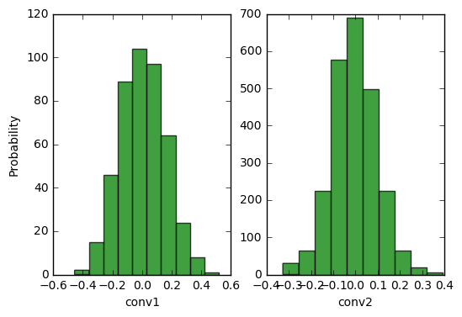
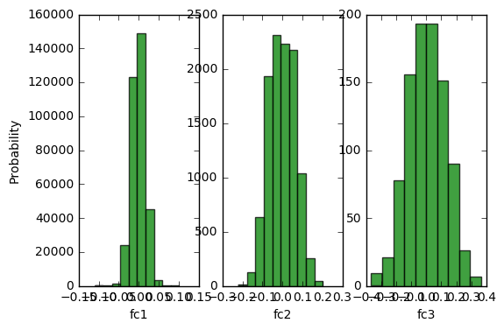
import numpy as np
import matplotlib.mlab as mlab
import matplotlib.pyplot as plt
​
def show_conv_bias_distribution():
for i in range(1, 3):
ax = plt.subplot(1, 2, i)
#ax.set_ylim([0, 20000])
plt.grid(False)
​
plt.subplot(1, 2, 1)
x = net.conv1.bias.view(-1,1).cpu().detach().numpy()
n, bins, patches = plt.hist(x, facecolor='green', alpha=0.75)
plt.xlabel('conv1')
plt.ylabel('Probability')
​
ax = plt.subplot(1, 2, 2)
x = net.conv2.bias.view(-1,1).cpu().detach().numpy()
n, bins, patches = plt.hist(x, facecolor='green', alpha=0.75)
plt.xlabel('conv2')
​
plt.show()
​
def show_fc_bias_distribution():
for i in range(1, 4):
ax = plt.subplot(1, 3, i)
#ax.set_ylim([0, 20000])
plt.grid(False)
​
ax = plt.subplot(1, 3, 1)
x = net.fc1.bias.view(-1,1).cpu().detach().numpy()
n, bins, patches = plt.hist(x, facecolor='green', alpha=0.75)
plt.xlabel('fc1')
plt.ylabel('Probability')
​
ax = plt.subplot(1, 3, 2)
x = net.fc2.bias.view(-1,1).cpu().detach().numpy()
n, bins, patches = plt.hist(x, facecolor='green', alpha=0.75)
plt.xlabel('fc2')
​
ax = plt.subplot(1, 3, 3)
x = net.fc3.bias.view(-1,1).cpu().detach().numpy()
n, bins, patches = plt.hist(x, facecolor='green', alpha=0.75)
plt.xlabel('fc3')
​
plt.show()
​
show_conv_bias_distribution()
show_fc_bias_distribution()
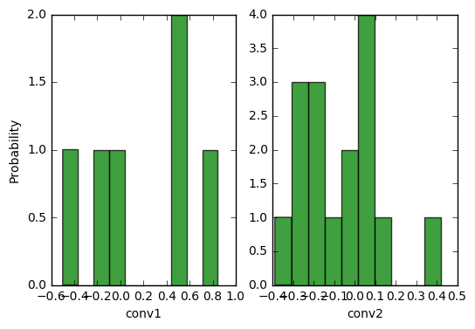
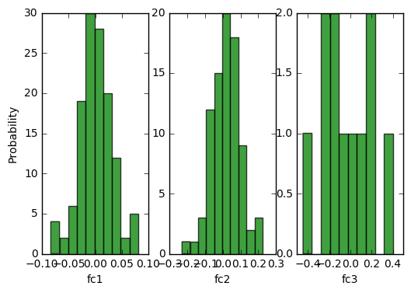
#After training , save the model first
#You can saves only the model parameters or entire model
#Some difference between the two is that entire model
#not only include parameters but also record hwo each
#layer is connected(forward method).
#[document]: https://pytorch.org/docs/master/notes/serialization.html
​
print('==> Saving model..')
​
#only save model parameters
torch.save(net.state_dict(), './checkpoint.t7')
#you also can store some log information
state = {
'net': net.state_dict(),
'acc': 100.*correct/len(trainset),
'epoch': 75
}
torch.save(state, './checkpoint.t7')
​
#save entire model
torch.save(net, './model.pt')
​
print('Finished Saving')
==> Saving model..
Finished Saving
/home/ccma/anaconda3/lib/python3.5/site-packages/torch/serialization.py:241: UserWarning: Couldn't retrieve source code for container of type Net. It won't be checked for correctness upon loading.
"type " + obj.__name__ + ". It won't be checked "
########################################################################

5. Test the network on the test data
########################################################################
#Before testing, we can load the saved model
#Depend on how you save your model, need
#different way to use it
print('==> Loading model..')
#If you just save the model parameters, you
#need to redefine the model architecture, and
#load the parameters into your model net = Net() checkpoint = torch.load('./checkpoint.t7') net.load_state_dict(checkpoint['net'])
#If you save the entire model net = torch.load('./model.pt')
print('Finished Loading')
print('==> Testing model..')
​
#Set the model in evaluation mode
#[document]: https://pytorch.org/docs/stable/nn.html#torch.nn.Module.eval
net.eval()
​
==> Testing model..
Net(
(conv1): Conv2d(3, 6, kernel_size=(5, 5), stride=(1, 1))
(pool): MaxPool2d(kernel_size=2, stride=2, padding=0, dilation=1, ceil_mode=False)
(conv2): Conv2d(6, 16, kernel_size=(5, 5), stride=(1, 1))
(fc1): Linear(in_features=2704, out_features=128, bias=True)
(fc2): Linear(in_features=128, out_features=84, bias=True)
(fc3): Linear(in_features=84, out_features=11, bias=True)
(relu): ReLU()
)
######################
#######LAB 1-1########
"""
To Do Here
​
You should complete the testing step in LAB 1-1
You should show the total accuracy & loss [10000 cifar10 test cases]
You also need to tell us, how about the accuracy for each class

For example: Total accuracy is: 60.0% and loss is: 0.02
For each class in cifar 10:
Accuracy of plane : 58.0%
Accuracy of car : 22.4%
.
.
.
"""
######################
correct = 0
total = 0
running_loss = 0.0
​
class_correct = list(0. for i in range(11))
class_total = list(0. for i in range(11))
​
with torch.no_grad():
for data in testloader:
images, labels = data
​
if device == 'cuda':
images = images.cuda(0)
labels = labels.cuda(0)
else:
images = images.cpu()
labels = labels.cpu()

outputs = net(images)
_, predicted = torch.max(outputs, 1)

total += labels.size(0)
correct += (predicted == labels).sum().item()
​
loss = criterion(outputs, labels)
running_loss += loss.item()
​
c = (predicted == labels).squeeze()
#print(predicted)
#print(labels.size(0))
#print(c)
for i in range(labels.size(0)):
label = labels[i]
class_correct[label] += c[i].item()
class_total[label] += 1
​
print('Accuracy of the network on the %d test images: %.2f%%, and loss is: %.3f'
% (total, 100 * correct / total, running_loss / total))
​
for i in range(11):
print('Accuracy of %5s : %2d %%' % (
classes[i], 100 * class_correct[i] / class_total[i]))
Accuracy of the network on the 3347 test images: 49.66%, and loss is: 0.048
Accuracy of Bread : 24 %
Accuracy of DairyProduct : 21 %
Accuracy of Dessert : 42 %
Accuracy of Egg : 42 %
Accuracy of Friedfood : 49 %
Accuracy of Meat : 57 %
Accuracy of Noodles-Pasta : 46 %
Accuracy of Rice : 15 %
Accuracy of Seafood : 58 %
Accuracy of Soup : 70 %
Accuracy of Vegetable : 79 %
​
​
​

​

